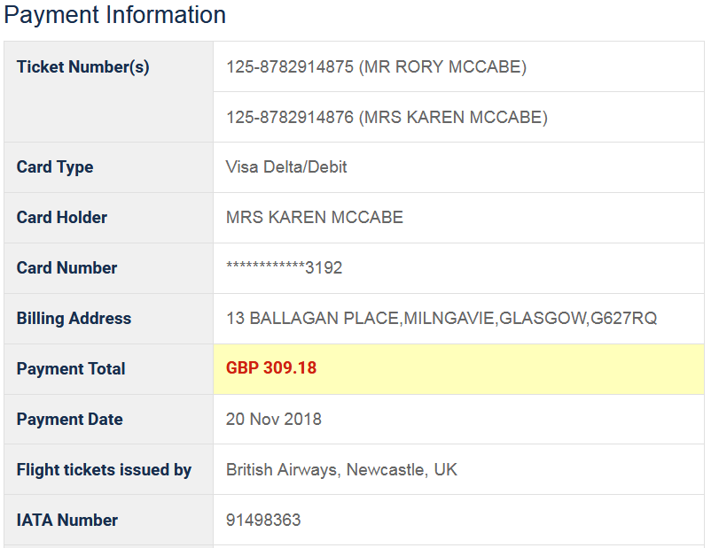

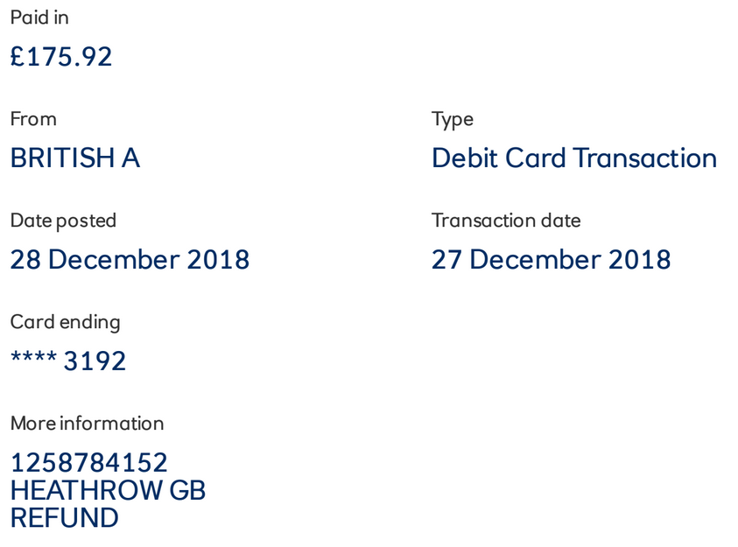

**Difference = £309.18 - £175.92 refund for Gatwick cancellation due to drone interference = £133.26 paid for two people => £66.63 each**